SpellSmart Logbook Entry

*This Log Book sates all the process and the steps I have done in order to start my Software Design Project and the changes that have under gone in order for the program to work. This logbook shows the process of the game called Spellsmart.*

**03/04/2017**

So today I had my first change with my program, I started with Java Script and discovered that it was harder so I have changed to Python version 3.4.4. This program will only be able to be accessible on a Windows and possibly Mac computer.

The layout of the program starts with:

* Welcome screen (Play Button) and (Quit button)
* Username screen – This is where the user will be able to a user name and later on they will have a score attached to their username.
* The Game itself the user will be able to spell the word with the allocated picture
* User will have a couple lives
* Target demographic will be young children who want to learn to spell
* The score will be held in a high score list

**15/04/2017**

I have managed to start working on the images, these images have taken a while to work on. Creating the images there are 2 different types of images

* The 1st is the Happy and sad faces when the user spell the word correctly or incorrectly
* The 2nd is the images used for the user to spell when playing the game

.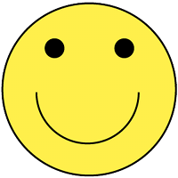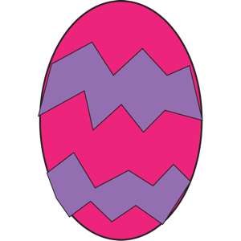

These are a few examples of the pictures that have been made for the game. I spent a lot of time working on the game pictures.

I have also spent time on some sounds that I have created using a program called Sibelius and some internet programs to make some sounds so when the user has the word correct there is a ding sound and when there is a word that is spelt incorrectly there is a Grrr sound. All these images and sounds have been allocated in separate folders.

**19/04/2017**

The game code has been started. The start screen is in progress. I am having a problem in terms of positioning the buttons.

I have recently taken a interest into starting my terms and conditions document which is in a notepad document. Here are a few site of sample terms &conditions:

* <https://termsfeed.com/blog/sample-terms-and-conditions-template/>
* <http://legal123.com.au/how-to-guide/how-to-write-terms-and-conditions/>

I have decided to use the Skypes Terms and conditions as a template for my terms

Here is the progress of the start screen.

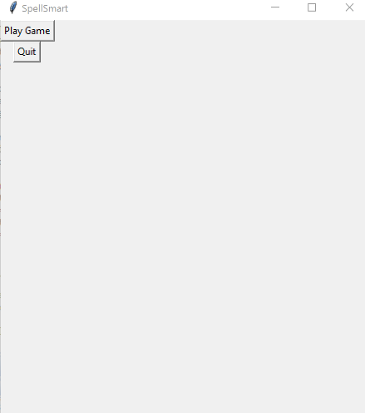

Here is the problem where the buttons are small and positioned at the top left hand corner.

**29/04/2017**

So the main code for the game has started with the set of Arrays for the:

* Pictures

Here are the list of the pictures that are linked to the words. The array of words and whether or not the word is correct or incorrect.

* Question
* Answers
* Words



The list of words and the list of pictures had to be put in order and match each other or else the different picture will show up for a different word, and will be completely different. Asked for Mr Lia’s help due to my buttons not working, later on figured out how to make the buttons active

**05/05/2017**

A new button has been added to the start screen and that is the {How to Play button}. This button will give the user a quick tutorial/rundown on how to play the game.

**06/05/2017**

All Buttons are complete and finalized; a text box has been added so that the user is able to type in the word giving the user the full experience. I also coded a point system so that when the user spells the word correct they will gain +1 to there score. The score system shows how many words the user has spelt correctly and incorrectly.



**23/05/2017**

Been looking at a few websites for help interms of tkinter. The good thing about tkinter is that it shows a fully functional application/GUI. So far it seems that I am on track.

* <https://stackoverflow.com/questions/28795859/how-can-i-play-a-sound-when-a-tkinter-button-is-pushed-python-3-4>
* <http://www.python-course.eu/tkinter_layout_management.php>
* <http://www.python-course.eu/tkinter_dialogs.php>
* <http://www.python-course.eu/tkinter_menus.php>

**05/06/2017**

I have managed to get the pictures fully working. And the games seems to working soothly. Every time the user moves to the next word is a new level and they get a final score of all the altogether. Unfortunately, I still am unable to get the song or the sound affects to work. And looking at various sites.

**09/06/2017**

The Setup Manual has been Completed and finished. The Terms & Conditions are very simple and not sophisticated.

**14/06/2017**

Unfortunately, I cannot get the sound affects to work, there are major syntax errors that pop up, and once those errors are gone, some parts of the game don’t show.

Overall, the game looks like a success. And I am very proud on how it is design.

**15/06/2017**

This is what the final product looks like:

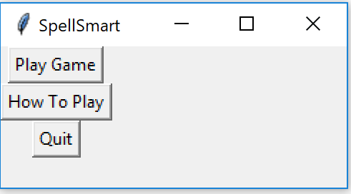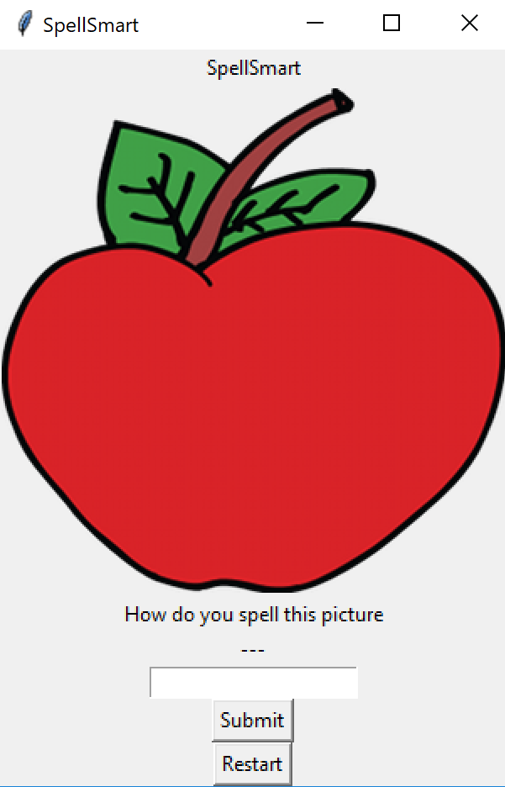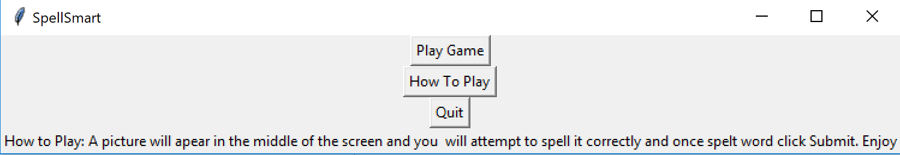

**16/06/2017**

Game is complete same goes with the whole assignment.